1.Sun Tracking Device

Project Description: -

This project aims to design and implement a solar tracking system that optimizes the efficiency of solar panels by dynamically adjusting their orientation based on the sun’s position. The system utilizes an Arduino as the main controller, a PCA9685 PWM driver for precise servo motor control, and two MG995 servo motors to enable dual-axis movement.
Four Light Dependent Resistors (LDRs) are strategically placed to detect sunlight intensity, providing real-time data for tracking the sun’s movement. The servos adjust the panel’s horizontal (X-axis) and vertical (Y-axis) angles, ensuring it remains perpendicular to sunlight for maximum energy absorption.
This solar tracker improves solar panel efficiency by increasing exposure to direct sunlight throughout the day, making it suitable for renewable energy applications. The system is cost-effective, easy to implement, and significantly enhances solar power generation compared to fixed panels.

Apparatus: -
S. No. | Component | Specification | Quantity
1 | Arduino | Any compatible board (e.g., Uno) | 1
2 | PCA9685 PWM Driver | 16-channel PWM driver | 1
3 | MG995 Servo Motor | 180° rotation | 2
4 | Light Dependent Resistor (LDR) | High-sensitivity photoresistor | 4
5 | Solar Panel | Small-scale panel for testing | 1
6 | Resistors | 10kΩ (for LDR voltage divider) | 4
7 | Battery/Power Supply | 5V or 12V (as per system requirement) | 1
8 | Jumper Wires | Male-to-male, male-to-female | As needed
9 | Perf-Board | Standard prototyping board | 1
10 | Frame/Stand | To mount the electronics | 1

Connection Diagram: -
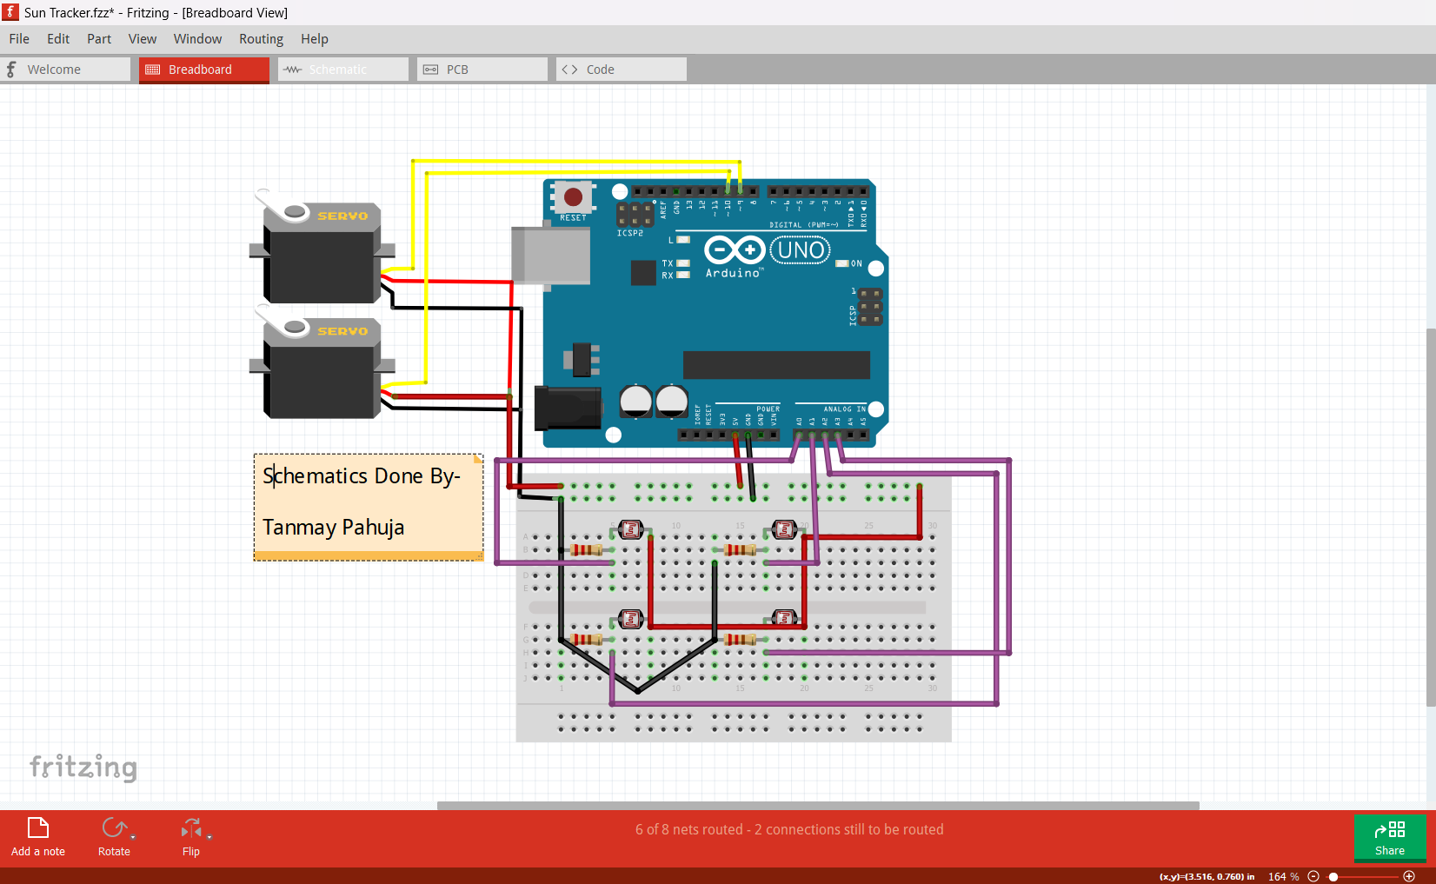

1. Arduino to Servo Motors (PWM Control)
Servo Motor | Arduino Pin | Power | Ground
X-axis Servo (Horizontal) | PWM Pin 9 | 5V | GND
Y-axis Servo (Vertical) | PWM Pin 10 | 5V | GND
2. LDRs to Arduino (Voltage Divider Setup)
Each LDR is connected in series with a 10kΩ resistor to form a voltage divider. The middle point of each divider is connected to an analog pin on the Arduino.
LDR Position | Arduino Pin | Other End
Top Left (LDR1) | A0 | 5V
Top Right (LDR2) | A1 | 5V
Bottom Left (LDR3) | A2 | 5V
Bottom Right (LDR4) | A3 | 5V
Resistor (10kΩ) | GND | Middle of Divider
3. Power Supply
- Arduino powered via USB or 5V adapter.
- Servos powered by an external 5V power source (if high torque is needed).
- Common ground (GND) between Arduino, servos, and LDR setup.

Code: -
int topleft;
int topright;
int downleft;
int downright;
int waittime = 1;

void setup() {
pinMode(9, OUTPUT);
pinMode(10, OUTPUT);
TCCR1A = 0;
TCCR1A = (1 << COM1A1) | (1 << COM1B1) | (1 << WGM11);
TCCR1B = 0;
TCCR1B = (1 << WGM13) | (1 << WGM12) | (1 << CS11);
ICR1 = 40000;
OCR1A = 3000;
OCR1B = 3600;
}

void loop() {
topleft = analogRead(A0);
topright = analogRead(A1);
downleft = analogRead(A2);
downright = analogRead(A3);

if (topleft > topright) {
OCR1A = OCR1A + 1;
delay(waittime);
}
if (downleft > downright) {
OCR1A = OCR1A + 1;
delay(waittime);
}
if (topleft < topright) {
OCR1A = OCR1A - 1;
delay(waittime);
}
if (downleft < downright) {
OCR1A = OCR1A - 1;
delay(waittime);
}
if (OCR1A > 4000) {
OCR1A = 4000;
}
if (OCR1A < 2000) {
OCR1A = 2000;
}
if (topleft > downleft) {
OCR1B = OCR1B - 1;
delay(waittime);
}
if (topright > downright) {
OCR1B = OCR1B - 1;
delay(waittime);
}
if (topleft < downleft) {
OCR1B = OCR1B + 1;
delay(waittime);
}
if (topright < downright) {
OCR1B = OCR1B + 1;
delay(waittime);
}
if (OCR1B > 4200) {
OCR1B = 4200;
}
if (OCR1B < 3000) {
OCR1B = 3000;
}
}

Project Outcome: -
The dual-axis solar tracker successfully enhances the efficiency of solar energy collection by continuously adjusting the solar panel's orientation based on the sun’s movement. The Arduino-controlled system processes real-time data from four LDR sensors, ensuring that the panel remains perpendicular to sunlight throughout the day.

